15W Outdoor Horn Speaker (15W)
FOH-115H
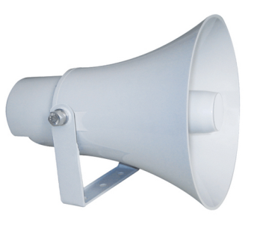
Feature:
- Commercial PA system paging horn speaker with transformer
- Ideal for outdoor paging and speech use in school, office, hotel and airport
- Economy rang weatherproof horn speaker
- Round shape reflex horn outdoor speaker
- Outdoor paging horn speaker for outdoor paging system
- Superior long distance human speech clear and loud delivery
- Rated power output 15W at 100V
- Waterproof level of IP66
- Line input 100V or 70V by cable tail
- ABS enclosure and stainless metal bracket in white
- Quick installation by supplied stainless mounting bracket

Specification:
Model | FOH-115H
Description | 15W Outdoor Horn Speaker
Rated Power Output | 15W
Line Input | 100V or 70V
Frequency Response | 300-8KHz
SPL(@1W/m) | 102dB
IP Rate | IP66
Connector | By speaker cable tail
Dimension | 230(W)×200(D)mm
Net Weight | 1.3kg
Material | ABS enclosure and stainless metal bracket in gray
Mounting Way | Quick installation by supplied stainless mounting bracket
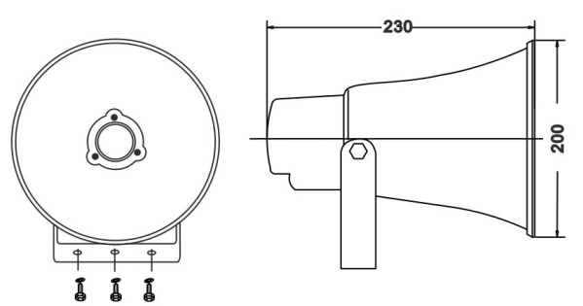
Dimension and Freq VS SPL Diagrams:

